* **Có 3 loại để truyền bean vào field**
  + **By Field**
    - **By Name**

VD:

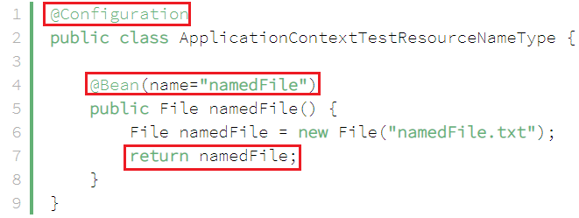

*Init bean by name*

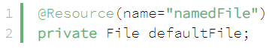

*Pass bean to field*

* + - **By Qualifier**

VD:

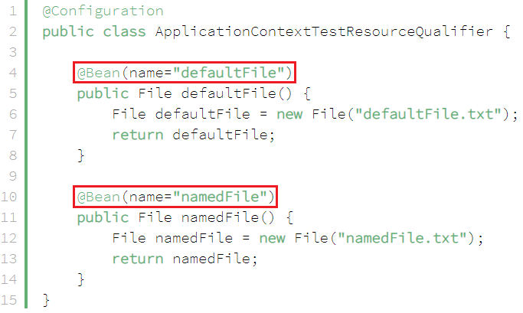

*Init bean by qualifier*

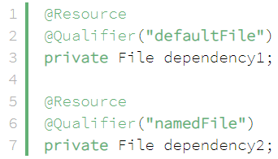

*Pass bean to field*

* + - **By Type**

VD:

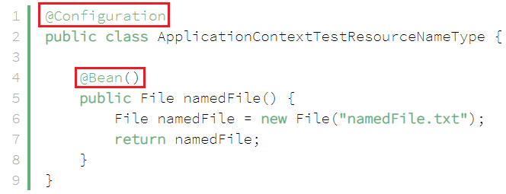

*Init bean by type*



*Pass bean to field*

* + **By Setter**
    - **By name**



*Init bean by name*

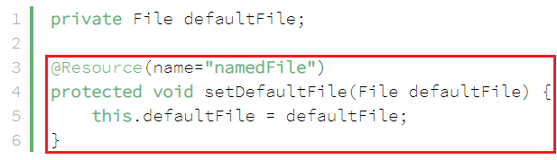

*Pass bean to field*

* + - **By qualifier**

Tương tự By Field

* + - **By Type**

Tương tự By Field

* **Reference**

<https://www.baeldung.com/spring-annotations-resource-inject-autowire#Resource>